August

20
,

2026

Lab

01

–

Introduction

to

Programming

Fundamentals.

Student Name: _Lubna Memon__________________________ Roll No: ___26k-0659_____________ Section: _BCS-1D_____________

Question 1: PAC
Create a PAC for a program that calculates the factorial of a non-negative integer. The program should ask the user for a number, then compute, and display its factorial (e.g., 5! = 120).
Given Data | Required | Processing | Solution alternatives
Non negative integer (n) | Factorial of (n) | Factorial=1  Read(n)  For i=1 to n  Factorial=factorial*n  End for | - Displays factorial of n when we ask the user to enter (n)  - Ex: If we have n=3 we multiply 3 with before 3 digit like 3*2*1=6  - If n=0 the loop does not run and factorial stays 1 so 0!=1

Question 2: IPO Diagram
Draw an IPO (Input-Process-Output) chart for a program that calculates the perimeter of a rectangle. Display the calculated perimeter.
Formula: Perimeter = 2 * (length + width).
Input | Processing | Module reference | Output
Length | Enter length | read | Perimeter of rectangle
width | Enter width | read
 | Calculate perimeter of rectangle=2(length+ width) | calc
 | Print perimeter | print
 | end | end

Question 3: Algorithm
Write a step-by-step algorithm for a process that calculates the square of a number.
- Step 01: Start
- Step:02: Input a number and store it in num
- Step:03: Processing(num*num)
- Step:04: Display square
- Step:05: end

Question 4: Pseudocode
Write pseudocode for a program that calculates the Simple Interest earned on a principal amount.
The formula for calculating Simple Interest is:
Simple Interest = (Principal × Rate of Interest × Time in Years) / 100
Start
Input Principal Amount, rate of interest, time in years,
Required: Simple interest
Simple Interest = (Principal × Rate of Interest × Time in Years) / 100
Output Simple interest
Stop

Question 5: Flowchart
Draw a flowchart that represents the process of calculating the volume of a cube.
Formula: (`volume = side * side * side`) and finish with displaying the output (the volume).
Start

Sides

Volume=Side*Side*Side

Volume

End

Question 6: Scratch Program
- Create a Scratch program where:
- When the green flag is clicked, it asks, "What is your favorite animal?"
- The user types the name of an animal.
- The sprite then says, "Cool! I like [user's animal] too!" for 3 seconds.
- The sprite then changes its costume to a different pre-existing costume and changes color.

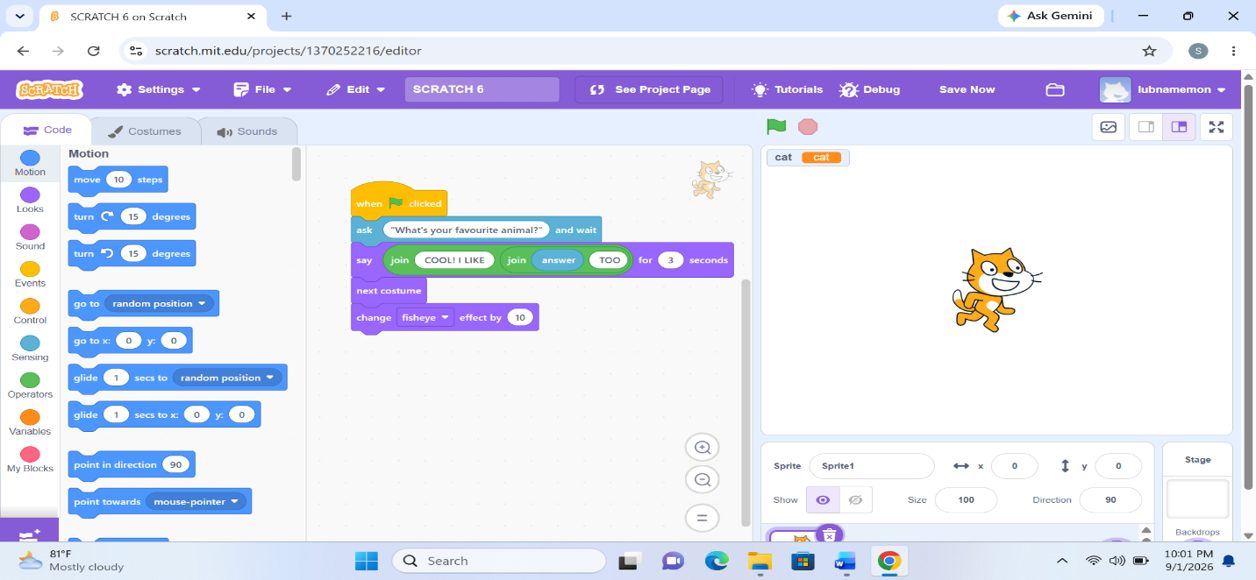
Prepared By: Miss Izzah Salam | Introduction to Programming Fundamentals 1

August

20
,

2026

Lab

01

–

Introduction

to

Programming

Fundamentals.

Student Name: ___________________________ Roll No: ________________ Section: _BCS-1D_____________

Question 7: Scratch Program
Create a Scratch program where a sprite gives a guided tour of the stage.
Use any background from the library (like "blue sky" or "stars"). When the green flag is clicked
The sprite appears in the lower-left corner of the stage, introduces itself (e.g., "Hello, I'm your guide!"), and waits 2 seconds. The sprite then glides smoothly to three different specific locations on the stage (e.g., the center, the top-right, and then back to the center). At each location, it should say what the location is for 1 second (e.g., "This is the center!". This is the top corner!").
After the tour is complete, the sprite should say "I hope you enjoyed the tour!"
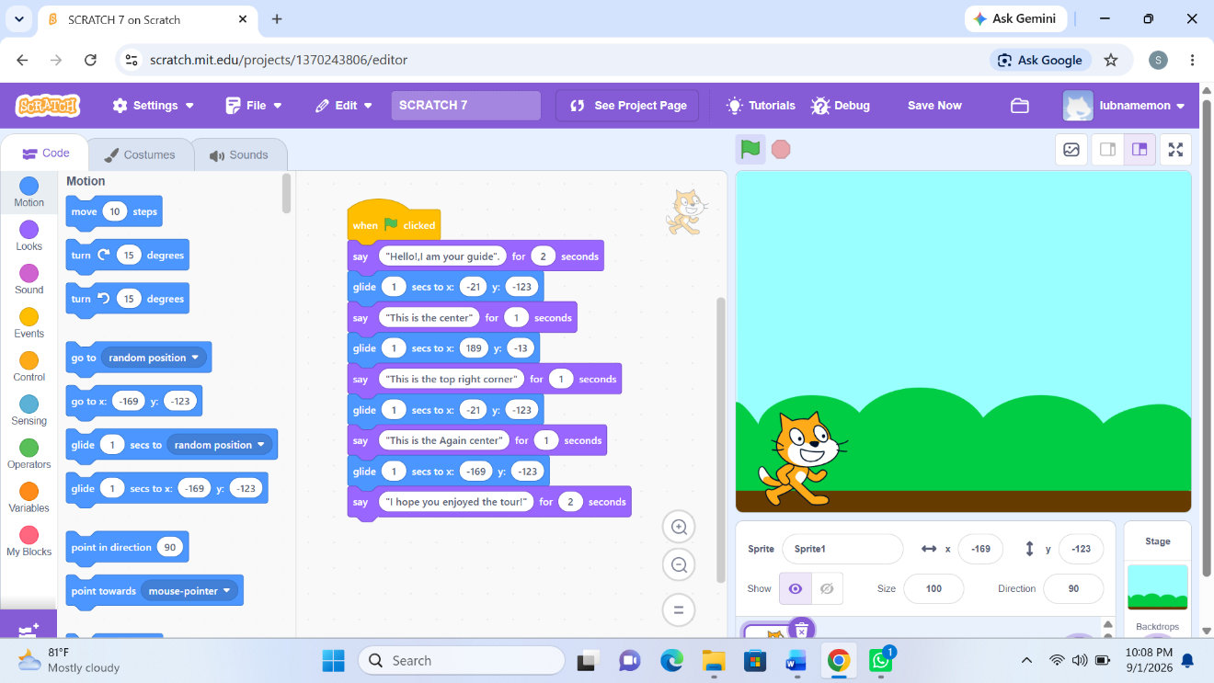

Prepared By: Miss Izzah Salam | Introduction to Programming Fundamentals 2

